Name: Jie MEI Student Number: 1030-29-9698

Homework 1: Macro Programming on a Linear System

1. Complete programs (macros) using attached template files
2. Completed:

1. Generate Matrix Vector

2. Load Matrix Vector

3. LU Decomposition: LU

4. Forward Substitution

5. Backward Substitution

(The code is attached with the Excel.)

1. Uncompleted:
2. LU Decomposition with row pivoting

(The code is attached with the Excel.)

Here is the problem I met.

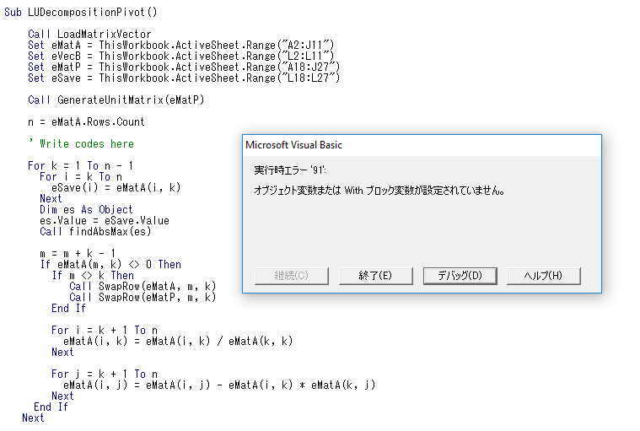

1. Solve a linear system with iteration methods
2. Completed:
3. Jacobi method
4. Gauss-Seidel method
5. SOR method

(The code is attached with the Excel.)

1. Generate a matrix by yourself (not using random number generator). Compare the convergence speed among Jacobi, GS, and SOR methods.

As the target function required，set the matrix and matrix bas follow.

After calculation with Jacobi, GS, and SOR (w=1 as original rate) methods in 100 iterations, we can obtain the different residues. The relationship between iterations and residues is presented in the figure 1.

Fig.1 change of the residues with iterations grow among different methods

As we can see in the figure 1, the sequence of convergence speed is SOR (w=1), Gauss-Seidel and Jacobi.

Then we can find the approximately optimal value of w - the Relax Parameter. After running the SOR algorithm in 300 iterations with different w within [0.1, 0.2, 0.3, 0.4, 0.5, 0.6, 0.7, 0.8, 0.9, 1.0, 1.1], the change currency of the residue can be obtained, which was presented in figure 2.

Fig.2 the change of the residue with different Relax Parameters

Fig.3 the comparison between w=1.0 and w=1.1

As the figure shown, with the Relax Parameter growing, the iteration in need increases after w=1.0, from which we can imply the approximately optimal value of the Relax Parameter is 1.0.